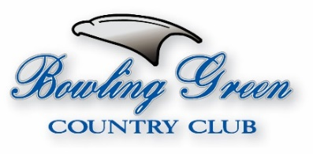
2021 B.G.C.C. Tournament Schedule
Thursday, April 1st Spring Match Play Tournament
(Plays April 1st – May 31st) (Limited to 32 players -USGA HDCP Required)
Sunday April 18th 2-Person Spring Opener
9am SG North Course
Saturday & Sunday May 22nd & 23rd Valley Masters
8am TT South & North Courses
Saturday & Sunday, June 26th & 27th B.G.C.C. Open Championship
8am TT South & North Courses (USGA HDCP Required)
Saturday, July 17th 2-Person Red, White, Blue Scramble
9am SG North Course
Saturday, July 31st 4-Person Hi/Low Shamble
9am SG South Course
Saturday, August 7th 2-Person Summer Shamble
9am SG South Course
Saturday & Sunday August 14th & 15th Member Club Championship
8am TT South & North Courses (BGCC Members Only – USGA HDCP Required)
Wednesday, September 1st Fall Match Play Tournament
(Plays September 1st – October 31st) (Limited to 32 players - USGA HDCP Required)
Sunday, September 19th 4-Person N.F.L. Shootout
9am SG South Course
Saturday, October 9th 2-Person Octoberfest Scramble
10am SG North Course
Saturday & Sunday October 23rd & 24th 2-Person B.G.C.C. Member Invitational
9am SG South & North Courses (BGCC Member/Member or Member/Guest Team)
(USGA HDCP Required)
Saturday, November 20th 4-Person Turkey Shoot Scramble
11am SG North Course
Saturday, December 4th 2-Person Frostbite Frenzy
11am SG South Course

